**DAILY ONLINE ACTIVITIES SUMMARY**

|  |  |  |  |  |  |  |  |  |
| --- | --- | --- | --- | --- | --- | --- | --- | --- |
| **Date:** | **31/05/2020** | | | | | **Name:** | **Manish B Shriyan** | |
| **Sem & Sec** | **8th sem B sec** | | | | | **USN:** | **4AL16CS131** | |
| **Online Test Summary** | | | | | | | | |
| **Subject** | | **IOT** | | | | | | |
| **Max. Marks** | | **20** | | **Score** | | | **17** | |
| **Certification Course Summary** | | | | | | | | |
| **Course** | **Developing Machine Learning Applications** | | | | | | | |
| **Certificate Provider** | | | **AWS** | | **Duration** | | | **2.5 Hours** |
| **Coding Challenges** | | | | | | | | |
| **Problem Statement:**  **To print pyramid patterns** | | | | | | | | |
| **Status: Solved** | | | | | | | | |
| **Uploaded the report in Github** | | | | | **Uploaded** | | | |
| **If yes Repository name** | | | | | **ManishShriyan** | | | |
| **Uploaded the report in slack** | | | | | **Yes** | | | |

Online Test Details:

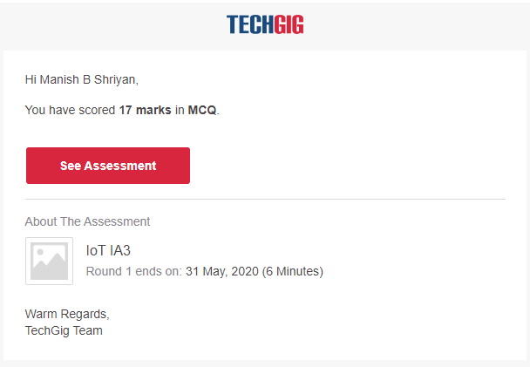

Certification Course Details:

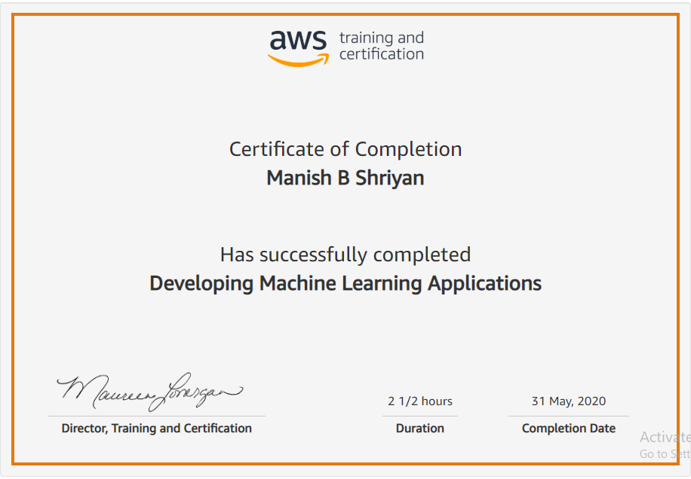

Coding Challenges Details:

rows = int(input("Enter the number of rows "))

for num in range(rows):

for i in range(num):

print(num, end=" ")

print(" ")